Serverless Development 101

**HOP02B – Install Serverless Framework**

1/10/2019 Developed by Kevin Wang

1/10/2019 Checked by Clark Jason Ngo

1/10/2019 Tested by Tuan Khai and Minh Truong

2/4/2019 Revised by Sam Chung

4/9/2020 Reviewed by Apiwat Chuaphan

Center for Information Assurance (CIAE) @City University of Seattle (CityU)



This course will take advantage of the Serverless framework. Serverless is a framework that can help software engineers to deploy the serverless application quickly. For more information, please visit <https://serverless.com/>

We will also create a profile in your local machine with the AWS Access key ID and AWS Secret access key you created in the last activity.

**Learning Outcomes**

* Install the Serverless framework and create a profile.

**Install the Serverless framework and create a Profile.**

1. Open a terminal.  
   (Windows: Windows + R, then “cmd”. MacOS: Command + Space, then “terminal”).
2. Type “node -v” and “npm -v” in the terminal to make sure you can see the version of NodeJS and NPM. (Your versions may be different from the example).

1. Type “npm i serverless -g” in the terminal.   
   Installation takes a while.   
   Note: Mac users may need super user’s permission.   
   Type “sudo npm i serverless -g” and password (your password for your laptop/local machine) for the super user.



For example, a Windows laptop shows the following information.  
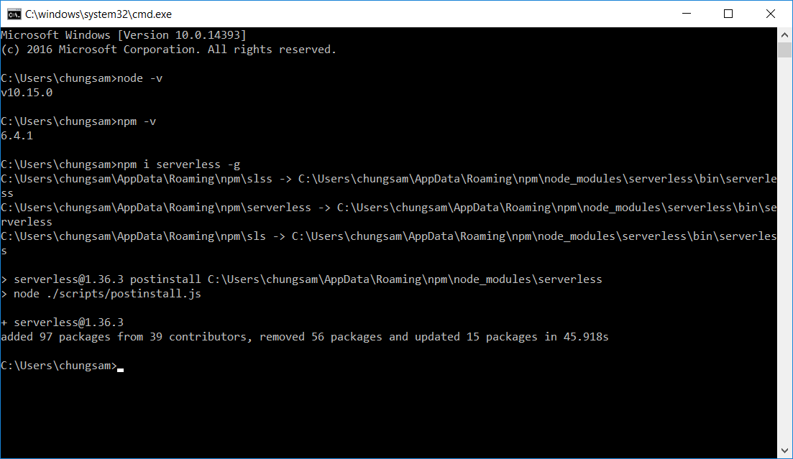

On macOS

1. After the installation finishes, type “sls -v” in the terminal to check the version of Serverless framework (sls is short for serverless).

1. Type “serverless config credentials --provider aws --key **YOUR_ACCESS_KEY** --secret **YOUR_SECRET_KEY**” in the terminal to create a profile in the local environment with credentials (you should replace the YOUR ACCESS KEY and YOUR SECRET KEY with your own keys).